Hydrogen Sulphide Sensor Specification

MICROceLTM HS - Hydrogen Sulphide

Performance Characteristics

Nominal Range
Maximum Overload
Expected Operating Life
Output Signal
Resolution
Temperature Range
Pressure Range
T50 Response Time
T90 Response Time
Relative Humidity Range
Typical Baseline Range
(pure air)
Maximum Zero Shift
(+20°C to +40°C)
Long Term Output Drift
Recommended Load
Resistor
Bias Voltage
Repeatability
Output Linearity
0-100ppm
1000ppm
Two years in Air
0.105 ± 0.025 ∝Α/ππμ
0.2ppm
-40°C to +50°C
Atmospheric ± 10%
<10 seconds
25 to 40 seconds typically
15 to 90% non-condensing
-2 to +1ppm equivalent

<0.2ppm equivalent

<5% signal loss/year
10Ω

Not required
<2% of signal
Linear
Outline Dimensions

17 ±0.2
5 CRS
Typ

2.8 ±0.2
Typ

Ο 8.25 ±0.2

Product Label

N.B. All performance data is based on conditions at 20°C,
50%RH, and 1013mBar unless otherwise noted.

Physical Characteristics
Weight 1.2g (approx.)

All dimensions in mm
All tolerances ±0.15mm unless otherwise stated

Position Sensitivity
Storage Life
Recommended Storage
Temperature
Warranty Period
None
Six months in CTL container
0°C to 20°C

12 months from date of
despatch

Doc. Ref.: microcelhs.pmd Issue 1.0
11th March 2004
Doc. Ref.: microcelhs Rev 02 Issue 2 ECN I 1281
2nd January 2007

Page 1 of 2

Page 1 of 2
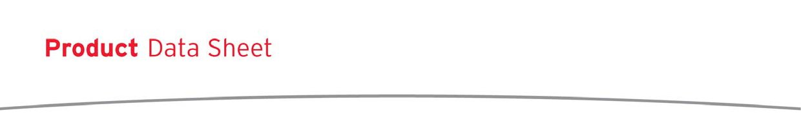

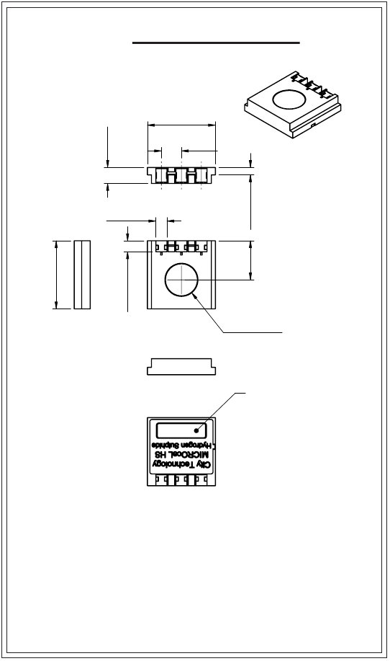



17±0.2
4±0.2
2.75±0.2
9.75±0.2
1.85±0.1

Hydrogen Sulphide Sensor Specification

MICROceL™ H2S Sensor - Output vs Temperature

115
110

105
100
95

90
85
80
Mean of 15 Sensors

75
70
Bars denote ±1⌠

-40
-30
-20
-10
0
10
20
30
40
50

Temperature (°C)
Effect of Temperature on the Shift in Mean Air Baseline Signals of Microcel HS Sensors
0.5
0.4
0.3
0.2
0.1
0.0
-0.1
-0.2
-0.3
-0.4
-0.5

-50
-40
-30
-20
-10
0
10
20
30
40
50
60

Temperature / °C

Cross-sensitivity Data

CiTiceLs may exhibit a response to certain gases in a sample other than the target gas. MICROceL™H2Ss have been tested
with a number of commonly cross-interfering gases and the results are given below. The table shows the typical response to be
expected from a sensor when exposed to a given test gas concentration (relevant to safety, e.g. TLV levels).

Gas
Carbon Monoxide:
Sulphur dioxide:

Conc.
15ppm
5ppm

MICROceL™H2S
0.1ppm
~1ppm

Gas
Hydrogen:
Nitrogen Dioxide:

Conc.
10000ppm
5ppm

MICROceL™H2S
<10ppm
~ -1ppm

Nitric oxide:
35ppm
~0.7ppm

**For details of other possible cross-interfering gases contact City Technology.**

Every effort has been made to ensure the accuracy of this document at the time of printing. In accordance with the company’s policy of continued product improvement City
Technology Limited reserves the right to make product changes without notice. No liability is accepted for any consequential losses, injury or damage resulting from the use
of this document or from any omissions or errors herein. The data is given for guidance only. It does not constitute a specification or an offer for sale. The products are always
subject to a programme of improvement and testing which may result in some changes in the characteristics quoted. As the products may be used by the client in circumstances
beyond the knowledge and control of City Technology Limited, we cannot give any warranty as to the relevance of these particulars to an application. It is the clients’ responsibility
to carry out the necessary tests to determine the usefulness of the products and to ensure their safety of operation in a particular application.
Performance characteristics on this data sheet outline the performance of newly supplied sensors. Output signal can drift below the lower limit over
Doc. Ref.: microcelhs.pmd Issue 1.0 Page 2 of 2
11th March 2004

Doc. Ref.: microcelhs Rev 02 Issue 2 ECN I 1281
2nd January 2007
Page 2 of 2

Output(%ofsignal@20°C)
BaselineShift/ppmH2S
time.

Thank you for evaluating AdreamSoft PDF to Word

You can only convert 3 pages with the trial version

To get all the pages converted, you need to purchase the software from

http://www.allpdftools.com/purchase/buy-pdf-to-word.html

